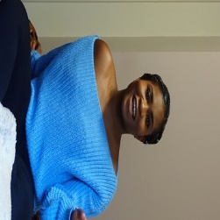
Hey!

I’m Dorcas, a 22 years old, postgraduate Education Leadership student. And I’m really excited to be putting myself forward for the new Vice President BME role for 2019-20.
Whilst I’ve not been actively involved with the SU, during my short time here at the university. I’ve had the privilege to be involved in faculty discussions involving around the issues of BME students. Which shows the university’s effort in confronting the nation’s work surrounding issues of BME students’ university experiences. For this reason, I feel compelled to take on this role, in order to be involved with the development of the SU in regards to this matter. By bringing in the skills and knowledge I have gained from my past experience as a part time sport and culture officer and vice president for the Nigerian society and athletics club at Bournemouth university, I believe that I will make the perfect candidate for this role in implementing changes to create a more inclusive environment for ALL students at the university.
Please take the time to look at my manifesto points and vote for me!

Manifesto points:
1. Introduce a multitude of intercultural events to UON, events that promotes and celebrates the culture diversity throughout the campus
2. Hold ‘safe space’ events that encourages and enables students to feel comfortable in expressing their concerns with respect to politics, religion and culture
3. Set-up BME networking events and career talks.
4. Work with the societies to ensure no student feels isolated and are able to find a community they can identify with.
5. Working with the university and other Sabbatical officers to ensure the BME students are considered in all their decisions

Areas of interest:
1. Develop the essence of cultural intelligence at the SU
2. To work with NUS on their campaigns throughout the academic year
3. Engage with issues of different ethnic minorities to transcend nationality, faith, class and the BME attainment gap.

If elected for this role, I promise to make the BME students at the heart of what I will be doing. A vote for me, will be a vote for representation across the university

