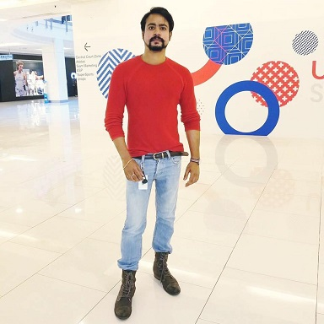
Hello! My name is Hamael Javaid, currently studying Master’s in Business Administration (MBA). I am contesting for the position of Vice President Union development in Student Union’s election 2019. I have been keenly involved as the Vice President of MBA society and would like to play my part in the union development of the university. If I get elected I would want to continue the exceptional work done by the previous VP development candidates before me.
A vote for me will be a vote for an enthusiastic and dedicated individual who is aware of your needs and requirements. My focus as a VP union development would be to seek funds to support all the existing societies of the university to give students opportunities to expand their horizons and release studies stress by getting involved in extra-curricular activities. I aim to support and provide opportunities within the university for development to student groups by supporting forums of collaboration and engagement.
I am approachable, understanding and a great listener who believes in working collaboratively with students to ensure they are heard. I aim to work with the relevant departments, societies and social media team to ensure that all activities, events and job fairs are advertised so that students can make the most out of them. I have relevant exposure to diverse nationalities, so I aim to utilize that to organise events to aid social and cultural interaction.

Objectives
1. I aim to find extensive 2-3 bodies to provide financial support for smooth running of societies and sponsor events outside university.
2. I intent to develop an online platform for students making it easier for them to book space for conducting meetings and events.
3. I aim to introduce a society of the month award to encourage the efforts, blood and sweat of students they put in running a society.
4. I want to develop inter-society partnerships once a month to provide diverse opportunities of learning and leisure for the students.
5. I aim to create awareness for student union events and societies and ensure that students are actively involved in this process.

Areas of Interest
1. UON’s societies active interaction and participation with students.
2. Effective usage of media to give a quick overview and promotions of the activities of student union and societies.
3. I plan to run weekly blogs to provide awareness of the activities run by the student union development.

