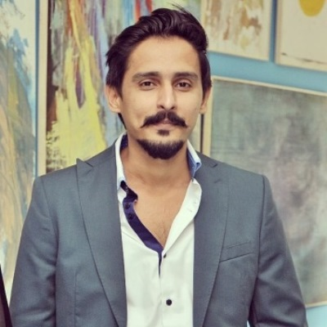
Hi I am Zain Ul Abideen, student of MBA and Treasurer of MBA society. I have spent most of my life in Pakistan although I have travelled several other countries in Middle East.
I have extensive post study experience working in Financial Services, Management Consultancies and Non-profits in Pakistan. I have worked with bodies like United Nations, Swiss Embassy in Pakistan, local, provincial and federal government representatives to solve the Non-Profit issues in Pakistan to improve the life of a left-out children in Pakistan. I am also working with several Charities in United Kingdom to support their cause.
I have a real understanding and genuine drive to sort out issues present students are facing in the University. I am also shadow treasurer of MBA Society and I have arranged several lectures for MBA students to help them not only in their current study but also useful in their future.
I want to ensure that future international and national students do not face some of the glitches faced.
My priorities for the coming year include:
1. To ensure diversity and that all nationalities, minorities as well as mature students have engagement in university extracurricular activities including societies;
2. To ensure economical and reliable accommodation for University students is not an issue to hinder their study;
3. Ensuring easier access to counselling services for students including how to management pressure;
4. Guidance on part time and placements will be clearer and all students will find it easier to work for their extra pocket money.

Vote for Diversity – Vote for your Well being - Vote for ZAIN UL ABIDEEN

